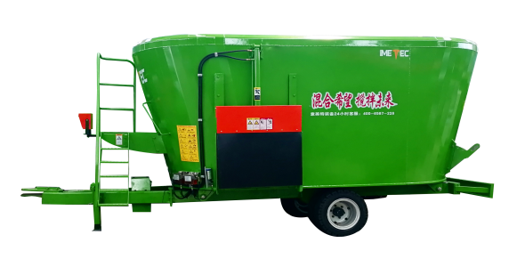
9JQL Vertical Traction TMR Parameter Table

project | Details | Standard configuration parameters
move  force  department  point | Model Specifications | 9JQL-36
move  force  department  point | Supporting power | 280 horsepower - 360 horsepower
move  force  department  point | speed reducer | R-series hardened gear planetary reducers
move  force  department  point | Gearbox Brands | Imported Kangmaier products, domestically produced Jiangling products
move  force  department  point | model | XHG05-51000.01
move  force  department  point | Two-stage reducer | Jiangling
move  force  department  point | model | XHG07-51000.03
all  machine  and  stir  mix  department  point | Spiral Dragon Form | Vertical
all  machine  and  stir  mix  department  point | Number of augers | 3
all  machine  and  stir  mix  department  point | Spiral material | Q355B manganese steel plate or NM360 wear-resistant steel plate
all  machine  and  stir  mix  department  point | Spiral speed | 22-29 rpm
all  machine  and  stir  mix  department  point | blade thickness | 16mm
all  machine  and  stir  mix  department  point | Blade material | Tungsten carbide alloy
all  machine  and  stir  mix  department  point | Number of blades | 21st CPC
all  machine  and  stir  mix  department  point | Blade thickness | ≤10mm
all  machine  and  stir  mix  department  point | Blade lifespan | ≥1500 hours
all  machine  and  stir  mix  department  point | Drive shaft (CM) | 1850mm
all  machine  and  stir  mix  department  point | Box thickness and material | 10mm Q355B manganese plate
all  machine  and  stir  mix  department  point | Base plate thickness and material | 20mm Q355B manganese plate
all  machine  and  stir  mix  department  point | Box filling method | Open
all  machine  and  stir  mix  department  point | Stirring speed | 18,000 tons/hour
all  machine  and  stir  mix  department  point | Each work time | 25 minutes
all  machine  and  stir  mix  department  point | Mixing time | 10 minutes
all  machine  and  stir  mix  department  point | Mixing uniformity | Binzhou screening test passed
all  machine  and  stir  mix  department  point | Forage cutting length | The length of the forage can vary from 2-6cm depending on the mixing time.
all  machine  and  stir  mix  department  point | Number of tires | 8
all  machine  and  stir  mix  department  point | Tire specifications | Tire size 295/60R22.5
Weighing section | Weighing system | Imported Italian DG/American Aesthetica 7.5T
Weighing section | Weighing sensor | 4 support points
Weighing section | Protection rating of weighing indicator | IP67
Weighing section | Weighing indicator control method | Fully automatic
Weighing section | Sensor maximum range | 30T
Weighing section | Measurement accuracy | 1/3000
Weighing section | Weighing indicator voltage | 12V
Discharge section | Control method | Hydraulic manual control valve
Discharge section | Number of doors opened | bilateral
Discharge section | Production efficiency (KG/H) | 14400-18000 kg/h
Discharge section | Total weight (kg) | (kg)
Discharge section | Overall machine dimensions (mm) | Approximately 9800*2550*3300 mm, subject to actual production specifications.
Discharge section | Note: Mechanical transmission is not allowed when using electric power; they must be separated (either mechanical or electric only). Tractor output requirement: 540 r/min



